Test Description: Smoke test McDonald`s app
Test Purpose: <Smoke test making delivery order >
Test Run Information:  Tester Name: Aviran buzaglo  Date of Test: 09/04/2024 | Prerequisites for this test: android device  phone-0526373847  email-aviranbuzaglo294@gmail.com  password-123456789  Id-123456789  Card number-5326105482765412  Card date-02/25  Cvv-781  Mobile- Xiaomi redmi note 11 pro
Software Versions1.4
Browser:
Operating System: Android

TEST SCRIPT STEPS/RESULTS
STEP | TEST STEP/INPUT | EXPECTED RESULTS | ACTUAL RESULTS | Requirements Validated | PASS/FAIL
Smoke – Functionality (positive)
Download and Sign up McDonald App
 | Go to play store on android phone | Play store will open | Play store has been open |  | Pass
 | Click on | Search dropdown will open | Search dropdown has been opened |  | Pass
 | Type "McDonald`s" | "McDonald`s" will fill | "McDonald`s" has been filled |  | Pass
 | Click on | Download will start | Download has started |  | Pass
 | Click on  | App will open | App has opened |  | Pass
 | Fill email address  "aviranbuzaglo294@gmail.com"  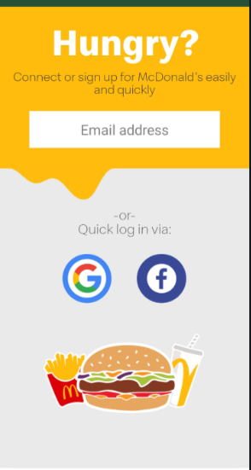 | Email will fill | As expected |  | Pass
 | Click on   | Menu will open  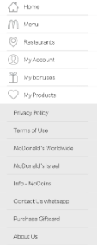 | Menu has been opened |  | Pass
 | Click on "my account" | Log in option will open | As expected  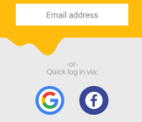 |  | Pass
 | Fill "aviranbuzaglo294@gmail.com" | Email will be fill | As expected   |  | Pass
 | Click on | A passcode will be sent by sms | As expected  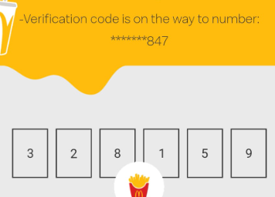 |  | Pass
 | Fill the code from the sms | The code will be enter | As expected  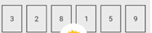 |  | Pass
 | My Address
 | Sanity
 | Click on | Menu will open | Menu has been opened |  | Pass
 | Click on  | My Account page will open  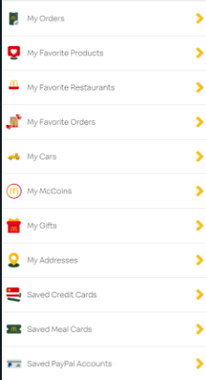 | As expected |  | Pass
 | Click on "My Address"   | Page of Address will open | As expected  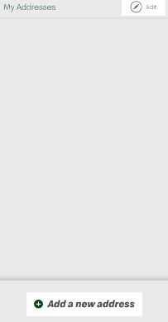 |  | Pass
 | Click on "Add a new address" | Page of address to fill will open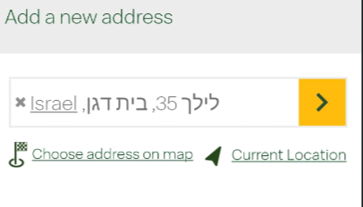 | As expected |  | Pass
 | Fill "לילך 35 ,בית דגן"  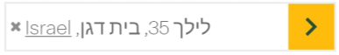 | Address "לילך 35 ,בית דגן" will fill | As expected |  | Pass
 | Click on 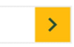 | Address "לילך 35 ,בית דגן" will be add | As expected |  | Pass
 | Smoke – order delivery
 | Click on | Menu will open | Menu has been opened |  | Pass
 | Click on "Home" | The Home page will open | As expected |  | Pass
 | Click on  | Pop up menu will open  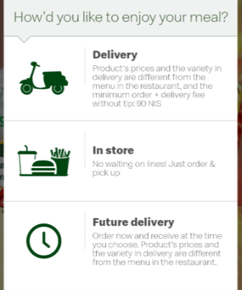 | As expected |  | Pass
 | Select "delivery"  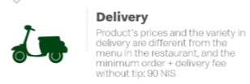 | Page with adding address will open | As expected  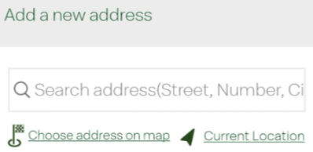 |  | Pass
 | Fill address"לילך 35 בית דגן" | Address will be fill  | - As expected  - Selection popup as been opened 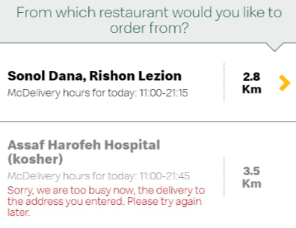 |  | Pass
 | Select a restaurant from the options | - A restaurant will be selected  - The food menu will open | - As expected  - 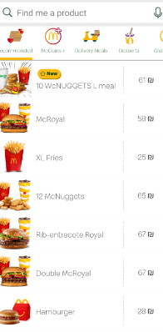 |  | Pass
 | Select "McRoyal" from the list | "McRoyal" detail page will open | As expected |  | Pass
 | Click on | "McRoyal" will be added to tray | As expected |  | Pass
 | Click on "my tray" 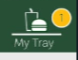 | Page "my tray" will open | Page "my tray" has open 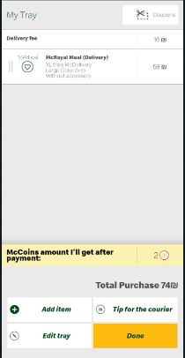 |  | Pass
 | Click on "Add item" | The menu will open | As expected |  | Pass
 | Select "Chicken royal" | "Chicken royal" detail page will open | As expected |  | Pass
 | Click on | "Chicken royal" will be added to tray | As expected |  | Pass
 | Click on "my tray" | Page "my tray" will open | Page "my tray" has open |  | Pass
 | Click on "Done"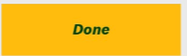 | Address detail page will open | As expected  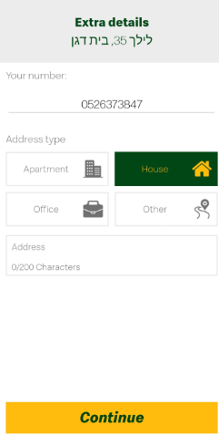 |  | Pass
 | Fill address "לילך בית דגן" | Address "לילך בית דגן" will fill | As expected |  | Pass
 | Click on  | Payment will pop up | As expected  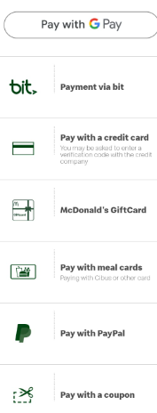 |  | Pass
 | Selecet "bit" | Bit app will open with payment approval | As expected  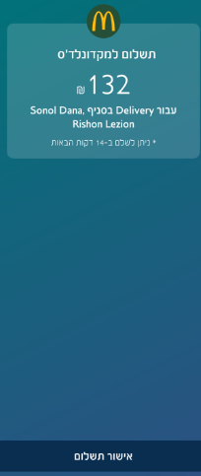 |  | Pass
 | Sanity –functionality
 | Open "McDonalds" app on your mobile | App will open | As expected |  | Pass
 | Click on  | Popup will show with option menu | As expected  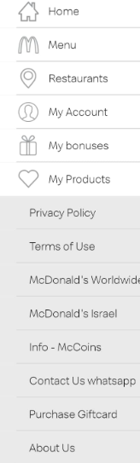 |  | Pass
 | Click on menu | Popup will show 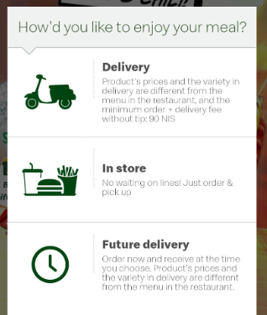 | As expected |  | Pass
 | Select "in store"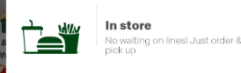 | Page of select restaurant will open | Page of select restaurant has show  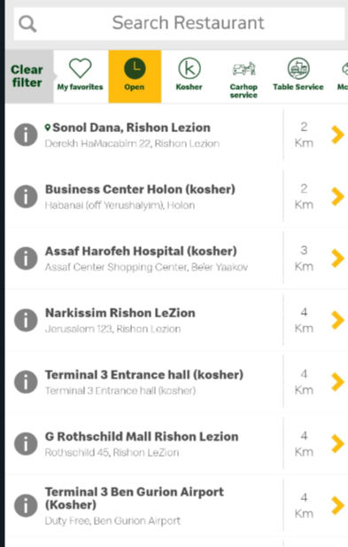 |  | Pass
 | Select  | Popup will show  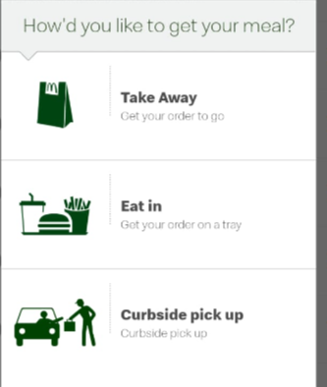 | As excepted |  | Pass
 | Select  | The menu will open | As expected  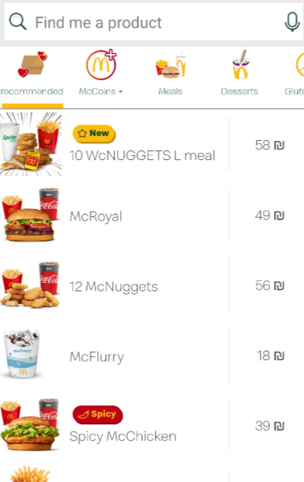 |  | Pass
 | Select "McRoyal" | McRoyal page will open  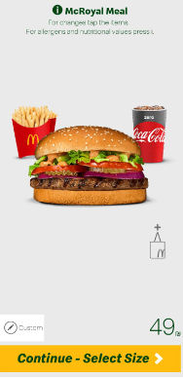 | As expected |  | Pass
 | Click on   | Popup "select size" will show  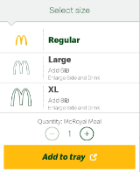 | As expected |  | Pass
 | Select "Regular" and "Add to tray" | The "McRoyal" will be add to tray | As expected  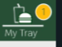 |  | Pass
 | Select "12 McNuggets" | - " 12 McNuggets" page will open  - Sauce Selection will show | - As expected  - Sauce selection has been open |  | Pass
 | Select 3 sauces from the list  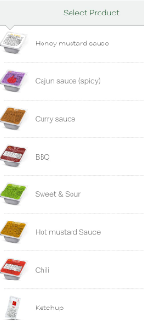 | 3 sauces will be add to order | As exepted |  | Pass
 | Click on "my tray" | Order page will open | As expected  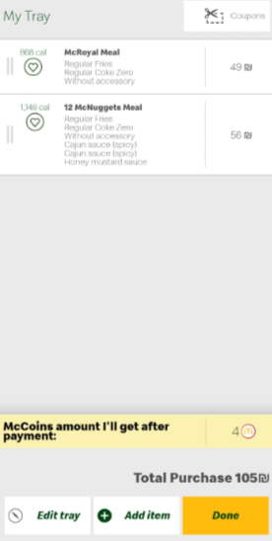 |  | Pass
 | Click on "Done" | Payment page will popup | As expected 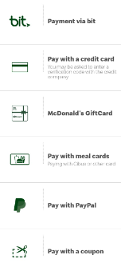 |  | Pass
 | Select payment  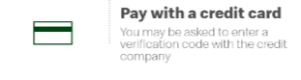 | Info page will open | As expected  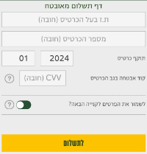 |  | Pass
 | Fill "ת.ז בעל הכרטיס" 123456789 | the "ת.ז בעל הכרטיס" will fill | As expected |  | Pass
 | Fill "card name" 5326105482765412 | The "Card Number" will fill | As expected |  | Pass
 | Fill "Card validity"02/25 | The "Card Validity" will fill | As expected |  | Pass
 | Fill "cvv" 781 | The "cvv" will fill | As expected |  | Pass

Test Description: sanity test McDonald`s app
Test Purpose: <sanity test making order >
Test Run Information:  Tester Name: Aviran buzaglo  Date of Test: 09/04/2024 | Prerequisites for this test: android device  phone-0526373847  email-aviranbuzaglo294@gmail.com  password-123456789  Id-123456789  Card number-5326105482765412  Card date-02/25  Cvv-781  Mobile- Xiaomi redmi note 11 pro
Software Versions - 6.0.8
Browser:
Operating System:

TEST SCRIPT STEPS/RESULTS
STEP | TEST STEP/INPUT | EXPECTED RESULTS | ACTUAL RESULTS | Requirements Validated | PASS/FAIL
sanity – Functionality (positive)
Order delivery
 | Open "McDonalds" app on your mobile | App will open | As expected |  | Pass
 | Click on | Popup will show with option menu | As expected |  | Pass
 | Click on menu | Popup will show 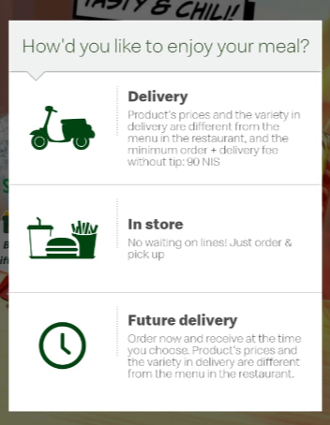 | As expected |  | Pass
 | Select "Delivery" | Address to deliver page will open  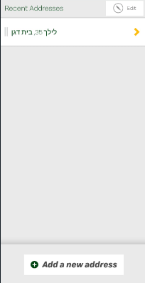 | As expected |  | Pass
 | Click on  | Selection of near restaurant will popup  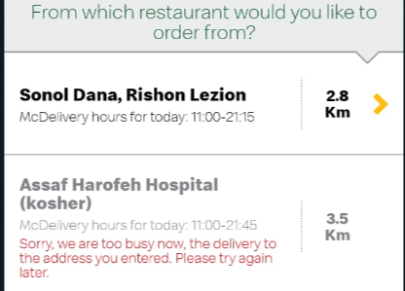 | As expected |  | Pass
 | Select  | Menu page will show | As expected |  | Pass
 | Select "McRoyal" | McRoyal page will open  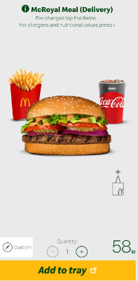 | As expected |  | Pass
 | Click on + 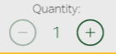 | Quantity will be add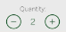 | As expected |  | Pass
 | Click on | "McRoyal" will be add to tray | As expected |  | Pass
 | Click on "my tray" | Tray page will open  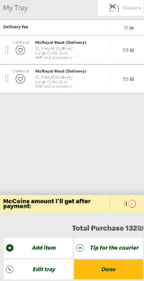 | As expected |  | Pass
 | Click on "Done"  | Extra details page will open 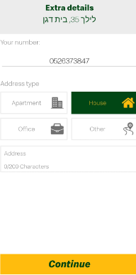 | As expected |  | Pass
 | Click on | Payment selection popup will show 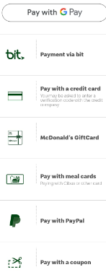 | As expected |  | Pass
 | Select payment | Info page will open | As expected  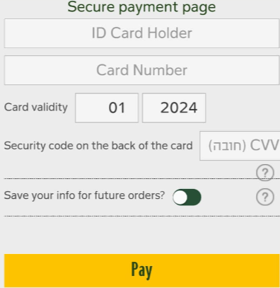 |  | Pass
 | Fill "ת.ז בעל הכרטיס" 123456789 | the "ת.ז בעל הכרטיס" will fill | As expected |  | Pass
 | Fill "card name" 5326105482765412 | The "Card Number" will fill | As expected |  | Pass
 | Fill "Card validity"02/25 | The "Card Validity" will fill | As expected |  | Pass
 | Fill "cvv" 781 | The "cvv" will fill | As expected |  | Pass
 | Click on  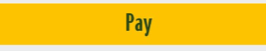 | The payment will proceed | As expected |  | Pass
 | sanity – Functionality (Negative) +error handling
 | Click on | Popup will show with option menu | As expected |  | Pass
 | Click on menu | Popup will show | As expected |  | Pass
 | Select "Delivery" | Address to deliver page will open | As expected |  | Pass
 | Click on | Selection of near restaurant will popup | As expected |  | Pass
 | Select | Menu page will show | As expected |  | Pass
 | Select "McRoyal" | "McRoyal" page will open | As expected |  | Pass
 | Click on "my tray" | Order page will open | As expected |  | Pass
 | Click on "Done" | "Extra details" page will open | Error of minimum order will show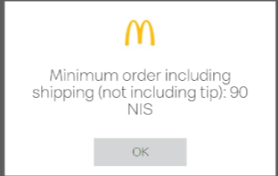 |  | Fail
 | Payment
 | Sanity-Error handling
 | Click on | Popup will show with option menu | As expected |  | Pass
 | Click on menu | Popup will show | As expected |  | Pass
 | Select "Delivery" | Address to deliver page will open | As expected |  | Pass
 | Click on | Selection of near restaurant will popup | As expected |  | Pass
 | Select | Menu page will show | As expected |  | Pass
 | Select "McRoyal" | "McRoyal" page will open | As expected |  | Pass
 | Order 120 "McRoyal" | 120 "McRoyal" will be add to tray | As expected |  | Pass
 | Click on "my tray" | Order page will open | As expected |  | Pass
 | Click on "Done"  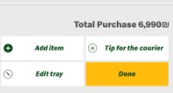 | Payment page will popup | Error message popup 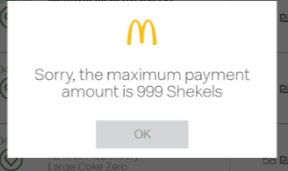 |  | Fail
 | Payment
 | Error handling-without network
 | Open "McDonalds" app on your mobile | App will open | As expected |  | Pass
 | Order "McRoyal" | "McRoyal" page will open | As expected |  | Pass
 | Click one time on + | Qantity will change to 2 | As expected |  | Pass
 | Click on | "McRoyal" will add to tray | As expected |  | Pass
 | Click on "tray" | Tray page will open | As expected |  | Pass
 | Close network conection on mobile | No service will accord | As expected |  | Pass
- fhfhf | Click on "done" | Payment popup will open | Error message has popup  As expected  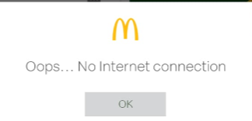 |  | Pass
- - | Restaurant
 | Interface positive
 | Click on | Popup will show with option menu | As expected |  | Pass
 | Click on "Restaurant" 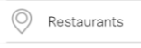 | Page with nearest restaurant will open | As expected |  | Pass
 | Click on  | Page with details on the restaurant will open | As expected |  | Pass
 | Click on  | Waze app will open | As expected  |  | Pass

